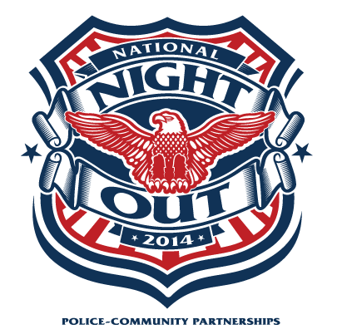 SRNA Sponsors -

National Night Out
August 5th, 2014
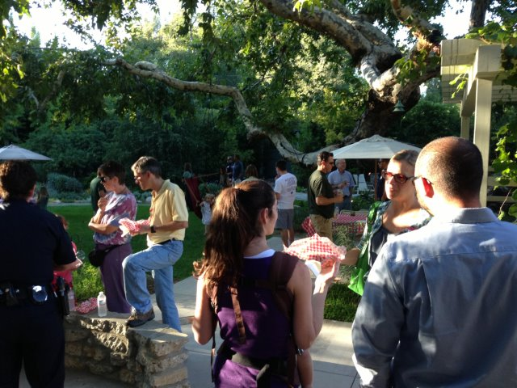

Tuesday, August 5th
6:00pm-8:30pm
455 Laguna Road
Pasadena, CA 91105
(North of La Loma Road)
Photo: SRNA 2013 National Night Out

*** FREE ***
Hot Dogs and Ice Cream
Old Fashioned Lemonade

(Special Appreciation to Robin’s Wood Fire BBQ)

BRING THE FAMILY!

“America’s Night Out Against Crime” promotes neighbor involvement in crime prevention practices where they live. The first National Night Out took place on Tuesday, August 7, 1984 with 2.5 million Americans participating across 400 communities in 23 states.

National Night Out now involves over 37.8 million people and 16,124 communities from all fifty states, U.S. Territories, Canadian cities, and military bases worldwide.

In support of Neighborhood Watch, last year SRNA introduced this nationwide event to the San Rafael neighborhoods, partnering Pasadena police and fire departments with neighbors to establish relationships focused on neighborhood safety and crime prevention.

WE WELCOME YOU AGAIN IN 2014!

SRNA supports the National Association of Town Watch (NATW) and National Night Out (NNO).
For more information go to: www.natw.org

www.srnapasadena.org SRNA-NNO2014

