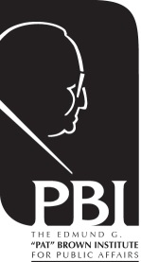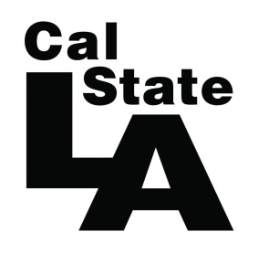

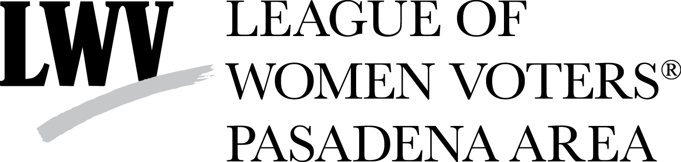

Invite you to an Issue Forum:

State Route 710 North
Extend or Not?

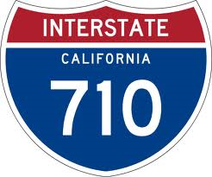

Monday, March 9, 2015
6:00 p.m. – Reception
7:00 p.m. - 8:30 p.m. – Program
Cal State Los Angeles, Golden Eagle Ballroom

Moderator: Dr. Raphael Sonenshein, Executive Director,
Pat Brown Institute for Public Affairs at Cal State L.A.
Panelists to be announced – check social media for updates
Contact PBI at 323-343-3770

Registration Here: http://tinyurl.com/SR-710NForum

'Like' us on Facebook and share this event:
“Follow” us on Twitter@PBI: https://twitter.com/PBI

